How to Prepare for the SHRM-CP/SHRM-SCP Exam with the SHRM Learning System

Presenters: Elizabeth Moore, SHRM-SCP
Director, Program Development
Dr. Ed Sherbert, SHRM-SCP
President, Sherbert & Associates
October 5, 2016

© 2016 SHRM

4 Steps to Success

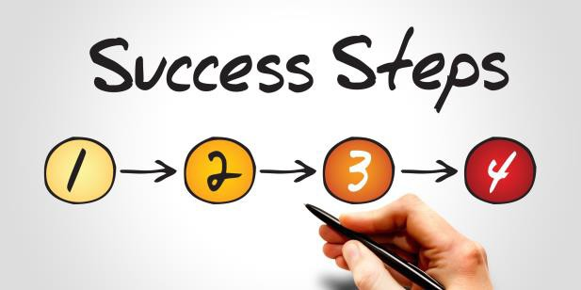1. Review Certification
Value & Requirements
2. Identify a Preparation
Program to Increase
Success
3. Define a Solid Study
Plan
4. Prepare for the Exam

© 2016 SHRM 2

1

Step 1: Review Value and Requirements

Demonstrates to employers an HR professional has current and relevant skills and competencies

Provides a universal standard that is recognized around the globe
Delivers an opportunity to
learn practical skills and competencies to impact your job immediately
Validates proficiency as a business leader by testing knowledge and how you use that knowledge

© 2016 SHRM 3

SHRM-CP and SHRM-SCP Credentials

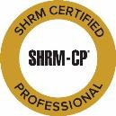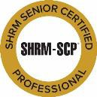▪ Two levels
▪ Managed by SHRM
Certification
Commission
▪ Supported by
world’s largest HR
organization
▪ Over 96,000 current
SHRM-CPs and
SHRM-SCPs

© 2016 SHRM 4

2

SHRM Body of Competency & Knowledge
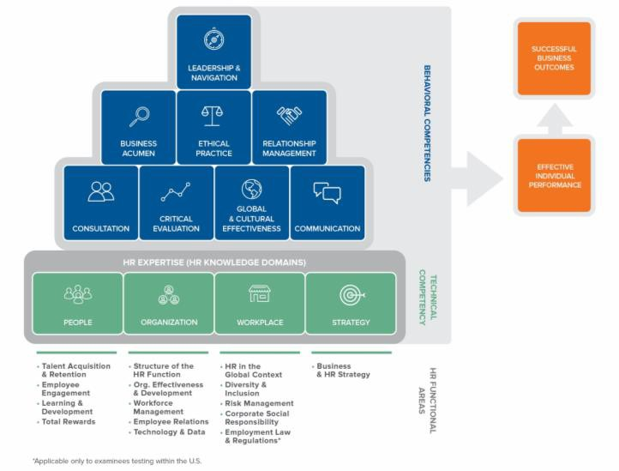 (SHRM BoCK™)

© 2016 SHRM 5

Sample BoCK Excerpt

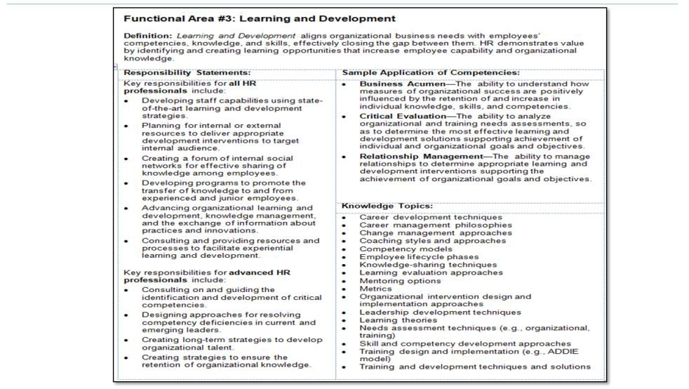© 2016 SHRM 6

3

SHRM BoCK Score Weightings

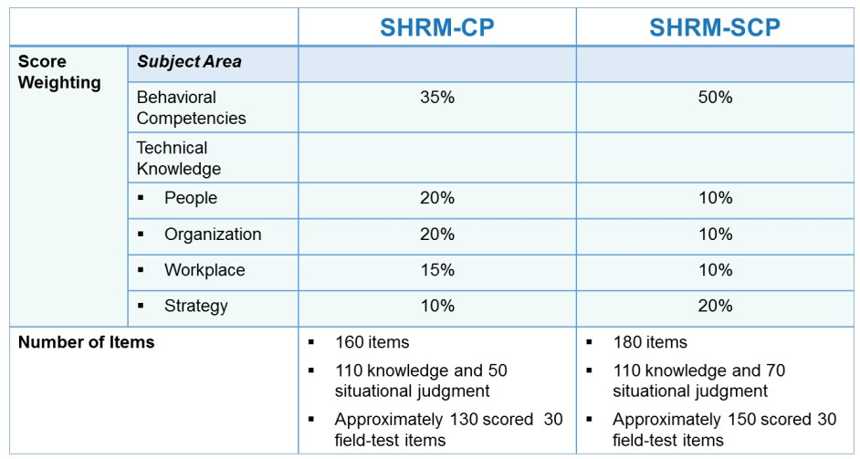

© 2016 SHRM 7

Eligibility Requirements

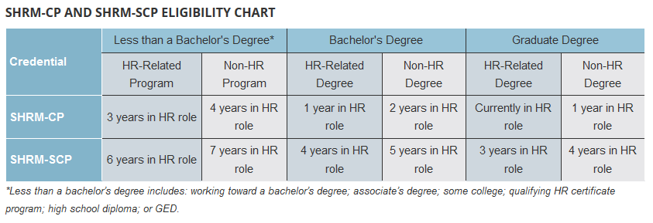

The SHRM certification program recognizes the value of formal HR education,
makes certification accessible to professionals with less-than-full-time work arrangements,
and provides a pathway from SHRM-CP to SHRM-SCP.

© 2016 SHRM 8

4

EXAM FORMAT AND LENGTH
▪ Computer-based testing (CBT)
▪ 160–180 questions (knowledge-based items and situational judgment test
items)
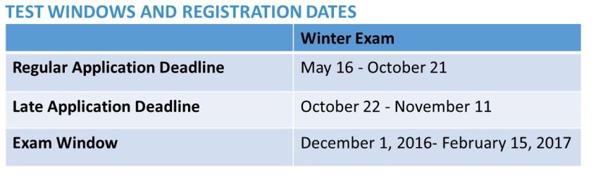▪ 3 hours and 40 minutes in length

CERTIFICATION CYCLE
All certifications are valid for three years.

© 2016 SHRM 9

Step 2: Identify a Program to Increase Success

Right content

Solid learning and reinforcement tools

Meets learning style and learning preferences

© 2016 SHRM 10

5

2016 SHRM Learning System
▪ Based on the SHRM BoCK tested on SHRM-CP and SHRM-SCP exams
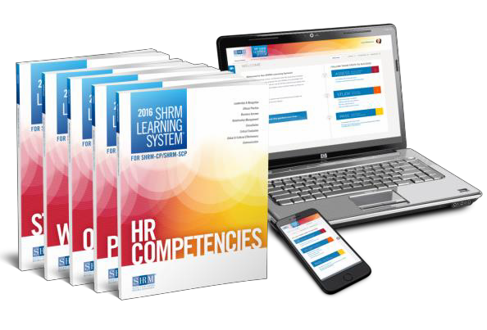▪ Comprehensive learning modules
▪ Interactive online media resources with over
1,500 practice questions
▪ Designed for adult
learners
▪ Proven system

© 2016 SHRM 11

Incorporates the SHRM BoCK

SHRM BoCK

Exam
Content SHRM Learning
System for
SHRM-CP &
SHRM-SCP

© 2016 SHRM 12

6

Reinforce Your Learning

• Choose SHRM-CP or SHRM-SCP study path–
encouraged to use both

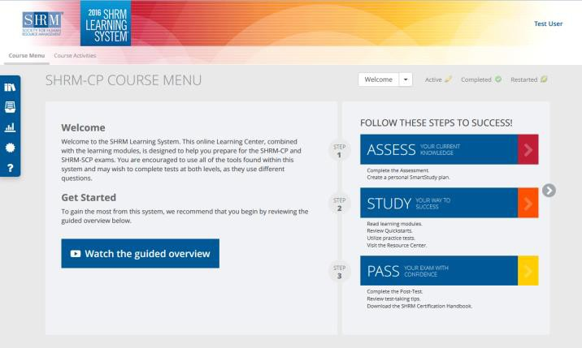TOOLBAR
▪ Resource Center
▪ Glossary
▪ Reports
▪ Certificate
▪ Help

© 2016 SHRM 13

Assess Your Knowledge

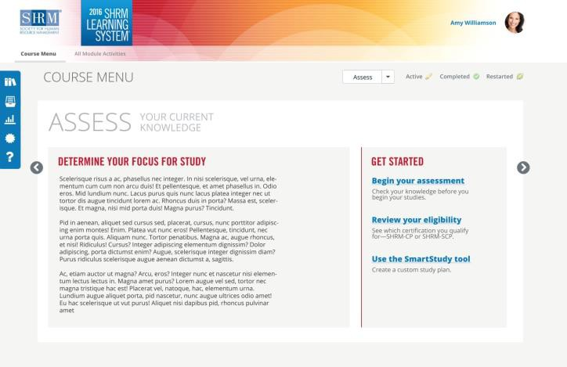▪ Assessment
▪ Eligibility
▪ SmartStudy
Tool

© 2016 SHRM
114

7

Study Your Way to Success

▪ Quickstarts
▪ Knowledge
Tests
▪ Situational
Judgment Tests
▪ Flashcards
▪ Download
eBook

© 2016 SHRM 15

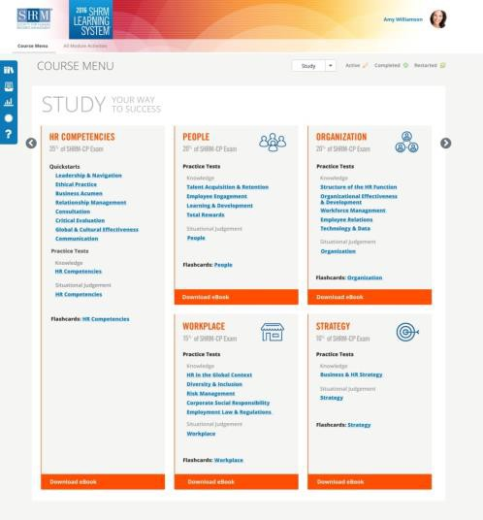Reinforce Learning Styles

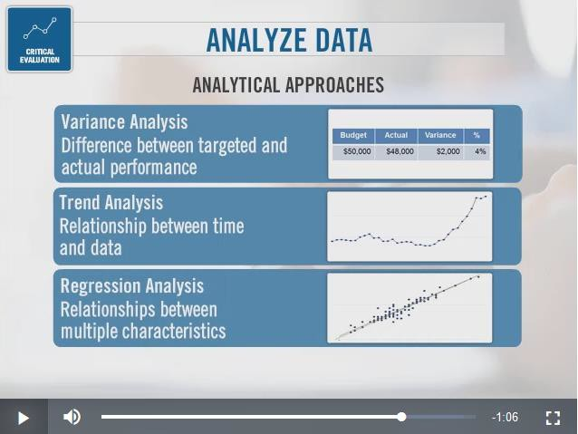Quickstarts are
high-level overview
videos that cover
the 8 behavioral
competencies.

© 2016 SHRM 16

8

Knowledge Question Example

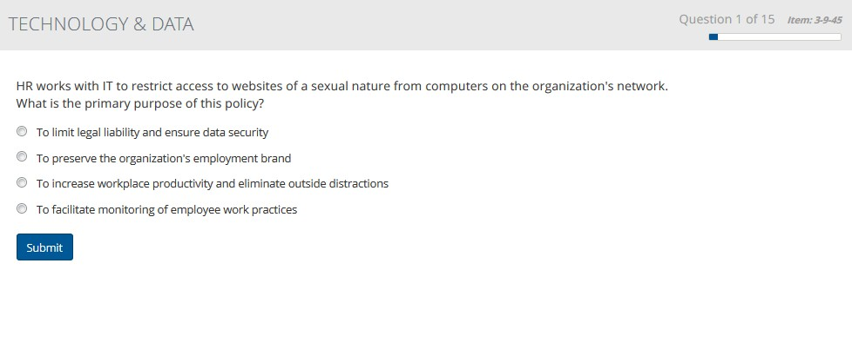Knowledge tests are multiple choice and test understanding of factual information.

© 2016 SHRM 17

Situational Judgment Question Example

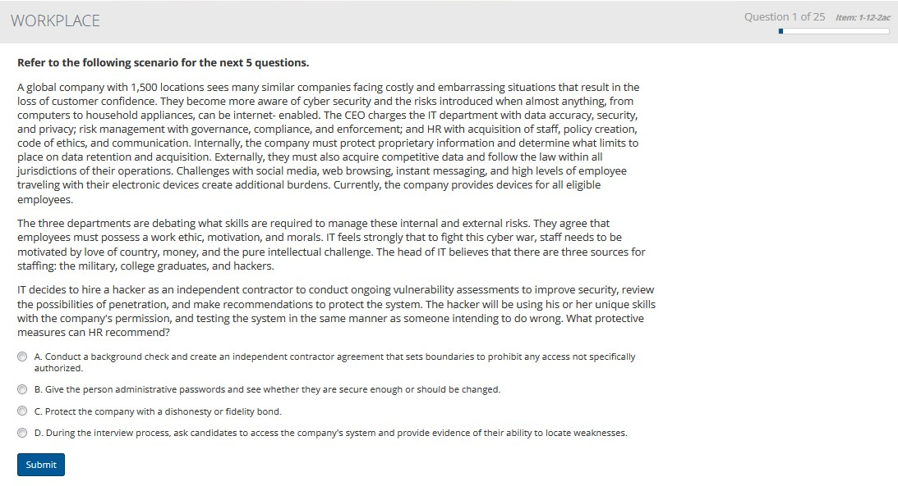The situational judgment tests assess judgment and decision making skills.
Full credit is awarded for selecting the preferred answer and partial credit for selecting the
acceptable answer. Zero credit is awarded for an incorrect answer selection.

© 2016 SHRM 18

9

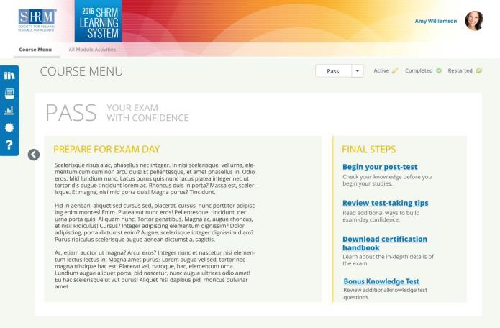▪ Post-Test
▪ Certification
Handbook
▪ Test taking Tips
Webcast
▪ Bonus
Knowledge Test

© 2016 SHRM 19

Post-Test

▪ Timer
▪ Strike-through
▪ Mark / Review
▪ See all answers/rationales
via this report

© 2016 SHRM 20

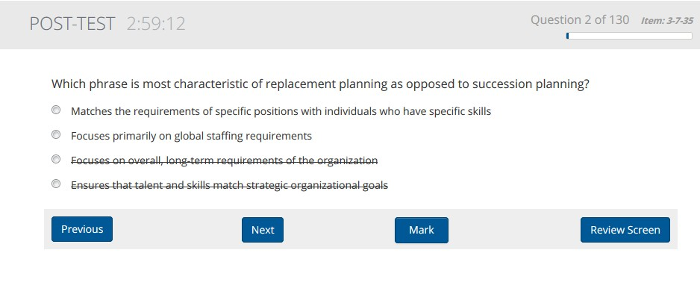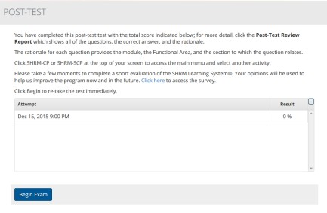10

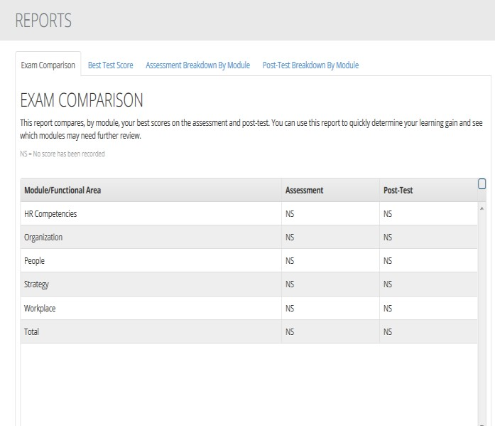Reports Include:
▪ Exam
Comparison
▪ Best Test Scores
(for knowledge
and SJ tests)
▪ Assessment
Breakdown
▪ Post-Test
Breakdown

© 2016 SHRM 21

Did You Know?

• Retention of new information without periodic review:
• 47% forgotten in 20 minutes
• 62% forgotten in 1 day
• 75% forgotten in 15 days
• 78% forgotten in 31 days

A single encounter with a given concept is not sufficient to ensure the type of long-term learning that is necessary for success on the exam.

© 2016 SHRM 22

11

Learning Options

Various learning options to meet your needs.

Self-study

SHRM Instructor-led 3-day intensive review and virtual courses

Instructor-led classroom or online through education partner

Corporate/in-house training

© 2016 SHRM 23

Step 3: Define a Study Plan

Identify
Which exam to take– SHRM-CP or SHRM-SCP

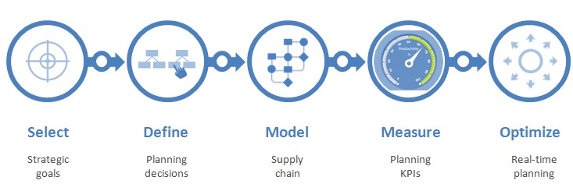© 2016 SHRM
Determine
Time you can commit and when to take exam
Assess
Your current knowledge and competencies
Evaluate
Exam weighting versus your skills
Plan
Appropriate resources and map for success

24

12

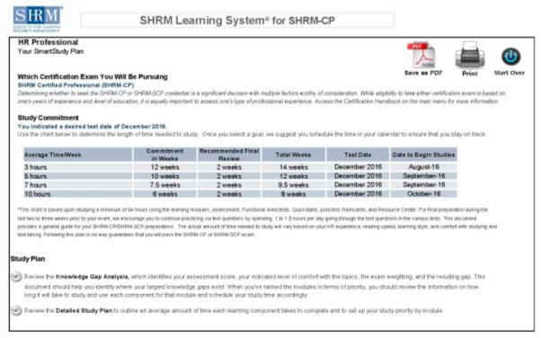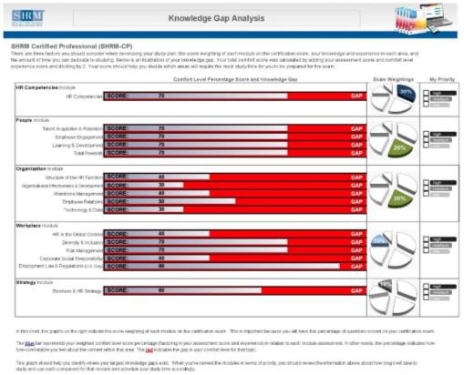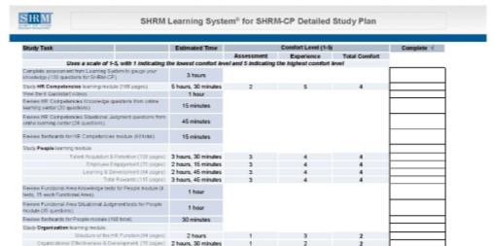SmartStudy Available In Learning System

▪ Students enter assessment and comfort level to set up custom study plan

© 2016 SHRM 25

Step 4: Prepare for the Exam

Trust your first impressions/avoid over-analyzing.

If uncertain, mark and return to question. Budget your time and don’t rush.
Identify your answer before reading the choices.

Eliminate obvious distractors.

© 2016 SHRM 26

13

Additional Information

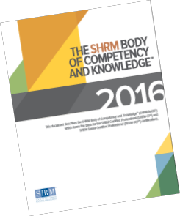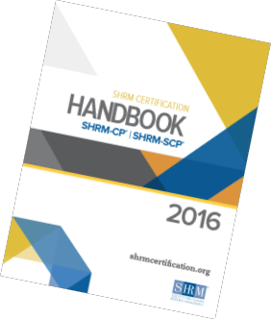▪ Preparing for certification—next steps:
▪ Understand SHRM BoCK
▪ Eligibility
▪ Exam
▪ Tools available:
▪ Certification Handbook
▪ SHRM BoCK
▪ SHRMCertification.org website

© 2016 SHRM 27

Special Offer

As a benefit of attending this Webcast, we are offering a $25 discount
on the SHRM Learning System* if you purchase prior to November 30, 2016.

To take advantage of this offer, you can:
• Visit shrm.org/learning and click on the Order Now button. Enter the code: LS06471. Be sure to click the My Cart link to access the discount code box before checkout.
• Call 800-444-5006, option #2, or +1-651-905-2663 and mention the code
LS06471.

Note: We recommend using materials developed in the same year that you will sit for the exam to ensure that you have the most current information.

*Offer applies only to the self-study learning option and cannot be combined with any other offers or previous orders.
Expires November 30, 2016

© 2016 SHRM 28

14

Testimonials
“I am extremely pleased with the SHRM Learning System. Both the print and online materials are very well-organized and have provided excellent preparation for the SHRM-CP exam. The SHRM BoCK covers all areas of HR and its focus on competencies and strategic alliance of HR with organizational goals provides an
updated focus. I completed my MBA with a specialization in HR only one year ago, and yet the SHRM Learning System provided information updated since that time. I would highly recommend
this system for anyone in or planning on entering the HR field.”

“I have been a practicing HR professional for over 20 years, but the competency-based content in the SHRM Learning System has truly caused me to reflect deeply and strategically on my own HR professional practices. It has empowered me to recharge and renew myself as an HR professional.”

© 2016 SHRM 29

15

