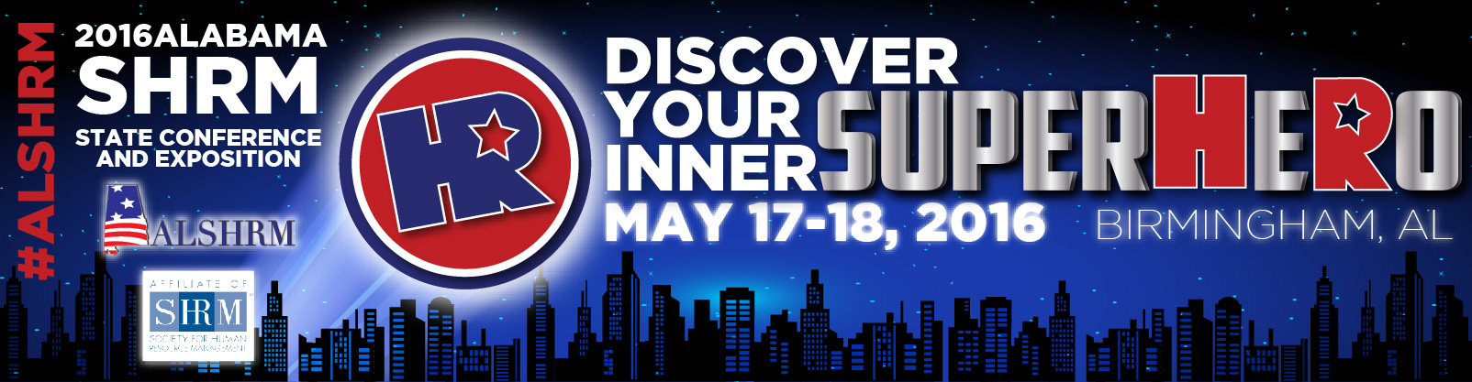Tuesday, May 17 Conference Day 1 Register online via alshrm.org 10.25 Certification credits
Conference Registration
11:00 am – 6:00pm……………..…………………………………………………………………………………………………………………………………….….........................................Escalator/Lobby

Session 1: 2016 Employment Law Update Presented by: Matthew Cannova, Maynard Cooper & Gale, PC
1:00 pm –2:15 pm………………………………………………………………………………………………..…….……………………………………………………………………….………………………East N-O

Session 2: The Black Guy in the C-Suite Presented by: Marlin Smith
2:30 pm- 3:45 pm …………………………..…………………………………………………………………………..….………………………………………………..………………………………………..East N-O

Session 3: Generation “THEM” (aka) What’s wrong with these people? Presented by: Kristin Scroggin
4:00 pm – 5:30 pm …………………………………………………………………………………………………………………………………….………………………………………………………..………..East N-O

ALSHRM 2016 Marketplace Event and Networking – Cocktail Hour
5:45pm -7:00pm …………………………..…………………………………………………………………………………………………………………………………………………………………………………… BJCC
Wednesday, May 18 Conference Day 2

Conference Registration
6:30 am – 8:30 am …………………………………………………………………..……………………………….……………………………………………………………………………………..Escalator/Lobby

Breakfast
7:00 am – 8:15 am …………………………………………………………………………………………………………………………………………..……………………………………………………………………..BJCC

Welcome & Announcements
8:15 am – 8:30 am…………………………………………………………………………………………………………..……………………………..………………………………………………………………………BJCC

Opening Keynote: Chuck Blakeman - Why Employees are ALWAYS a Bad Idea
8:30 am – 9:45 am………….……………………………………………………………………….…………………………………………………….…………………………………………………………………….. BJCC

Marketplace and Networking Break
9:45 am – 10:00 am………………………………………………………………………………….………………………………………………….……………………………………….………………………………BJCC

Concurrent Sessions
10:00 am – 11:15 am
- Background Screening: What You Don’t Know Can Hurt Your Organization
Presented by: Debra Keller ……………….…………………………………………………………………………………………………….……………………………………….East N-O
- Hazard Communication and GHS What Supervisors Need to Know
Presented by: Malcom Ritchie…………………………………….……….………….......................................................................................................East K-L
- Strategic Leadership Solutions: Building Vision, Alignment and Execution
Presented by: Mary White ……………………….……..........................................................................................................................................East M
Marketplace and Networking Break
11:15 am – 11:45 am……………………………………………………………………………………………….………………………………………………….…………………………………………………………………BJCC

Lunch & Lunch Keynote: Tim Sackett/ The New HR Math: Dumbing Down HR Analytics for Everyday HR Pros!
11:45 am – 1:00 pm ………………………………………………………………………………………………….………………………………………………………………………………………………………………….BJCC

Marketplace and Networking Break
1:00 pm – 1:15 pm…………………………………………………………………………………….……..….………………………………………………..……………………………………………………………………BJCC

Concurrent Sessions continued
1:15 pm – 2:30 pm
- Can Health Care Costs Fall While Employee Health Rises: A Case Study
Presented by: Cooper Johnson ……………..….…….……………………………………………………………..……………………………………….….…..……........................East N-O
- Finding Your Super Hero Voice in the Adventurous World of Recruiting
Presented by: Cord Sachs …………….……………………..……………………………….……..……………..……..….……………………………….…………..……………………….. East K-L
- The OC Equation - Unleashing Your Employees’ Passion, Potential and Performance through Organizational Culture
Presented by: Cindy Beresh-Bryant……………..…………………………………………….…………………………………………………..…….……….……....…………………….. East M

Marketplace and Networking Break
2:30 pm – 2:45 pm……………………………………………………………………………………………………....…..……………………………………………………………………………………………………...…BJCC

Closing Keynote Speaker: Avish Parashar/ Ding Happens! How HR Professionals Can Improvise, Adapt, and Innovate in an Ever Changing World
2:45 pm – 4:00 pm…………………………………………………………………………………………………………..……………………………………………….…………………………………………………………BJCC

Closing Comments and Door Prizes
4:00 pm – 4:45 pm………………………………………………………………………………………………………………………...………………………………….………………………………………………………BJCC

