Shoals SHRM – Board Meeting
11/9/2023 1pm 2023

Call To Order at

Attendance
Crystal Wilson - President, , Mallory Watkins – President – Elect, Matt Oglesby – College Relations, Erika Franco - Communication Officer, Committee Member - Emily Addison Collins , Christina Lewis - Finance Officer New board member Shericeia Abernathy
Absent Meghan Fike – Administrative Officer
Topic | Discussion
Call to order | All board members will help meet, greet, serve, setup and clean during monthly meetings.  Board member elections have been completed we only had 7 complete the survey. Will discuss best fit role and get back with everyone.  Need to discuss donation for SHRM Foundation amount. We agreed on $175 Donation for 2023 will review if we have additional funds to donate in 2024  Approved to pay for Meghan Fike SHRM membership $249 for 2024  UNA SHRM Certification Class teachers  Approved 2024 package deals and pay as you attend. Mallory will develop the new invoices  SHRM NATIONAL members only linked to Shoals Chapter  package deal - includes presentation and food  $125  Non-Chapter MEMBERS/VISITORS package deal  - includes presentation and food  $175  If you do not purchase the package deal the cost will be $20 for Guest and SHRM National Members  If the budget allows would purchase $100-$200 worth of Shoals Chapter/SHRM pad folios, pens, shirts, bags, for paid shrm members.  Currently we as board want to keep around $9,000 or more in our bank account for security if we needed to pay for speakers, purchase gifts, food, make additional donations or other items the board agree upon
Required For SHRM Affiliation | REQUIRED For SHRM Affiliation- Southeast Region  Four Board Meetings Required Per Year  Income/Expenses - Keeping up with Jan 1 beginning and Dec 31 ending balance  Membership Dues - Members must be SHRM National Members at shrm.org  Supporting and Promoting SHRM Foundation Initiative - Make a $ donation from Shoals SHRM in October/November  Promoting SHRM Certification - UNA/SHRM Certification Study Group  Board Member Elections – October  Chapter Leader Information Form CLIF – Due December 1 or when board members change  SHAPE deadline is January 31, 2024 for our chapter initiatives and financial statement  Promote SHRM Expo, State Council Meeting, etc.  Annual Reaffirmation for SHRM certification provider  HRCI recertification for credits  VLBM Volunteer Leader Business Meeting (board member must attend normally held in November Washington DC)
Business Cards/Logo | Logo was completed and submitted to SHRM for approval by Mallory Watkins 2023
Bylaws | Sent revision to approve Bylaws: remove irrelevant information and Dual membership chapter. This will be an ongoing project. Monique FSD is reviewing them
SHRM VLRC VOLUNTEER | Shrm.org-membership-volunteer leader resource center  Previous recorded volunteer webinars  Home (shrm.org)  Webinar (shrm.org)
Legislative Update – | SHRM A-Team member.  Sign up here! Take Action Download the APP  http://www.advocacy.shrm.org/about?0

College Relations Student Affairs – Matt Oglesby |  | Matt update on UNA student chapter:  STUDENT SHRM NATIONAL RATE $49  If more than 2 students attend the Shoals SHRM meetings, Matt will pay the $10 per student fee. ,  Future suggestion – Matt has had several student attend chapter meetings over the past year, una chapter meeting primarily virtually, Grace and Erin who work for UNA are good connections for recruiting for the business careers and job fairs, Steve Smith speaker with Applicant Pro (system is a HRIS system)  Matt will complete a study abroad in England in 2024
Income Statement/Finances-Christina Lewis  SHRM Deposit for membership  Q2 Financial Support Program  100% Chapters: $6.25 per SHRM Professional Member primarily coded* to your Chapter at the end of each calendar quarter. Paid quarterly and totaling $25 per year. |  | Income Statement as of 11/8/2023  Purchased goody bags and gift cards for money meetings average around $50  Purchase Tea monthly average $12, purchase plates, cups, napkins, utensils as needed average $50  Previous Balance -$ 10,597.86  Current Balance - $ 9,634.23  Upcoming purchases Holiday Event $100-$200, VLBM DC trip parking $90, SHRM Foundation Donation $175  Chapter payments 2022 SHRM Q4 $ $418.75 3/10  2023 SHRM Q1 $ 362.50 5/26  2023 SHRM Q2 $420.00 8/18  2023 SHRM Q3 $  Total National SHRM Members 57 (goes up and down, Crystal receives a daily report)  Post office $212.00 DUE September 2023  Meghan Fike membership $249 (varies annual)  Keeping up with Jan 1 beginning and Dec 31 ending balance  - This is required for SHRM affiliation  We have 27 paid package deals $2850  Possible locations – Listerhill Auditorium, Lauderdale County
Volunteer Activities/Workforce Readiness |  | Workforce Readiness Initiative for 2024- Discuss hosting a job fair & partnering with the Shoals Chamber/Stephanie Newland and businesses. We can use Listerhill facility in Muscle Shoals for the job fair.  Date – Free – Promote  City of Florence, list of new businesses.  Shoals Chamber contacts  SHRM Host Free Webinars on the VLRC and HRCI for Credits
 | Membership Roster= members  Current 57  Squareup-credit/debit card payment  (charges a fee so you don’t receive the full amount of the payment) $3.93 |  | Members must be SHRM National Members $249  January 1 - December 31, 2024  Membership dues  This is required for SHRM affiliation  SHRM NATIONAL members only linked to Shoals Chapter  package deal - includes presentation and food  $125  Non-Chapter MEMBERS/VISITORS package deal  - includes presentation and food  $175  If you do not purchase the package deal the cost will be $20 for guest and SHRM National Members  Reach out to expired members
 | Sponsorship Info |  | United way Donated Walmart $50 gift card 2/9/2023  United Way Donated Easter goody bag 3/9/2023  CIMSgts Ron Castro Sponsor $50 2/9/2023
 | SHRM Foundation Change  https://www.shrm.org/foundation/Pages/Donate-Now.aspx  New Fundraising website for chapters and state council  https://shrm.org/foundation/about/Pages/GiveSmart |  | Support and promote SHRM Foundation  Initiative - SHRM Foundation $Change$ - Collecting change in 2023  Make a $175.00 donation from Shoals SHRM in November 2023 - This is required for SHRM affiliation  **Foundation Scholarships Handout**
 | 2023 ALSHRM SHRM FOUNDATION DIRECTOR  Crystal Wilson  ALSHRM BOARD MEETING 1/26/2023, 5/2023, 8/2023 & 11/2023 |  | Save the Date ALSHRM Conference May 13-16 2024 Perdido Beach Resort  SHRM FOUNDATIONS SCHOLARSHIP 2023 available online  https://www.shrm.org/foundation/pages/default.aspx

Meeting Credits |  | Crystal Wilson has been submitting certification credits for meetings and conferences - HRCI & SHRM  October 2023 Completed Re-affirmation for SHRM Chapter Certification Provider for 2024  Will need Complete HRCI Renewal January 2024  Chapter Certification for credits
UNA/SHRM Certification Study Group 2024  https://www.shrm.org/certification/about/Pages/default.aspx  SHRM HOST CERTIFICATION WEBINARS  YOU CAN REPLAY THEM ON THE SHRM VOLUNTEER WEBSITE SHRM Volunteer/Core Leadership Area (CLA) Webcast/Webinar Information 2022 |  | Each instructor must be SHRM Certified  2024 SHRM certification exam window is May – July & December – February  Instructors: Crystal Wilson, Mallory Watkins, Rob Hildreth, Open  Shericeia Abernathy will be replacing Carlo Underwood for the 2024 Spring class  Promoting SHRM Certification This is required for SHRM affiliation – Post on Facebook & LinkedIn  SHRM eblasts for certification prep course (non – SHRM affiliated members)
Board Member Elections/Chapter Leader Information Form CLIF  https://fs16.formsite.com/robgatesshrmorg/form8/index.html |  | SURVEY MONKEY COMPLETED FOR 2023 FOR BOARD MEMBERS SEND OUT EACH SEPTEMBER/OCTOBER  This is required for SHRM affiliation.
SHAPE -Completed  https://drive.google.com/file/d/1WYhBfdWx96gkc1-ONk8iJkazhvwtqp33/view |  | SHAPE deadline is January 31, 2024 for our chapter initiatives and financial statement  Search for SHRM VLRC, may have to enter Shape in the search engine on the website for correct year. Answer  7-10 questions  Required for SHRM Affiliation  This is where we add and delete board members.
Board Meetings  4/2023  8/2023  10/2023  11/2023 |  | This is required for SHRM affiliation
SHRM Annual Conference |  | SHRM EXPO CONFERENCE 2024 June 23-26 Chicago, IL
Communication Officer |  | Mallory Watkins, Meghan Fike, Crystal Wilson - Update, Social Media, Flyers
Board Member Perks | Chapter will pay for Board members to attend UNA conference (if there is a conference held) if they chose to attend if their company will not pay  President, President-Elect/Vice/ Past President, Finance Officer, Administrative Officer, Communication Officer, Legislative Officer, Student Liaison board member, Program Director, Communication Director
Webinars & SHRM WEBINARS | Crystal has been sending out relevant webinars to the group and posting on the website  Meghan Fike has started our Shoals SHRM Facebook page and updating upcoming events  Mallory has started our LinkedIn SHRM page  https://www.shrm.org/learningandcareer/learning/webcasts/pages/default.aspx
Company Foundations | Kicks For Kids, Food Pantry, Toys For Tots, United Way, Books

2023 Meeting Dates  We will plan to meet in person unless speakers are unable to do so. | CRYSTAL ATTENDED  Thursday, November 9, 2023 – Robin Hunt Think Analytics  Save the Date: SHRM Volunteer Leaders' Business Meeting (VLBM) 2023: November 16-18, 2023, Washington, D.C. Invitation-only for select State Council and Chapter positions; more details to come. Mallory and Crystal Plan to attend  Thursday, December 14, 2023 – Holiday Open House Need to work on door prizes and Games  2024 Upcoming Events  Thursday January 11, 2024 Horizon Point Mary Illa  Thursday February 8, 2024 Carr/Allison Legal Update  Thursday March 14, 2024 Cierra Belser (ALSHRM) Breaking Barries: Inclusive Hiring Practices for Employers  Thursday April 11, 2024 Dr Ryan Gibson HPG Holistic Performance group Decatur-Thea Harvey-Barratt Emotional Intelligence  Thursday May 9, 2024 Matt Oglesby  May 13-16 2024 ALSHRM Conference more details to come  June 23-26 SHRM Annual Conference and Expo Chicago, IL  Thursday August 8, 2024 Rene Ramsey ALSHRM  Thursday September 12, 2024 Need Speaker (possible Robyn Hunt) Data Think  Thursday October 10, 2024 Need Speaker  Thursday November 14, 2024 Need Speaker  SHRM Volunteer Summit Washington DC more details to come November 2024  Thursday December 12, 2024 Open House Fun and Games  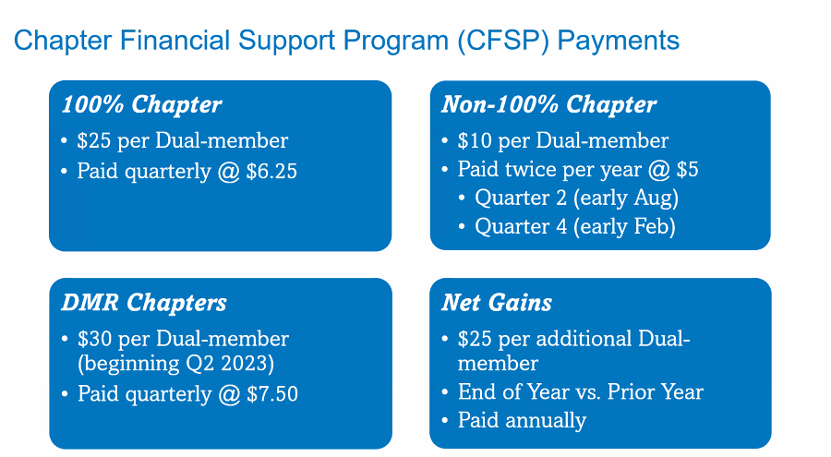  Southeast Region-Alabama, Bahamas, Bermuda, District of Columbia, Florida, Georgia, Kentucky, North Carolina, Mississippi, Puerto Rico, South Carolina, Tennessee, Virginia, West Virginia  MAC Representative Heather "HD" Deyrieux, SHRM-SCP Manager - Workforce Planning  Sarasota County Government Sarasota, FL Email: HDshrmMAC@gmail.com  State Council Websites  Alabama -- http://al.shrm.org/ Bermuda -- http://www.bhra.bm/  Bahamas -- http://bhrda.shrm.org/ Georgia -- http://shrmga.shrm.org/  Florida -- http://www.hrflorida.org/ Kentucky -- http://www.kyshrm.org/  North Carolina -- http://nc.shrm.org/ Mississippi -- http://www.msshrm.org/  Puerto Rico -- http://www.shrmpr.org/ South Carolina -- http://sc.shrm.org/  Tennessee -- http://tnshrm.shrm.org/ Virginia -- https://www.hrvirginia.org  West Virginia -- http://wv.shrm.org/  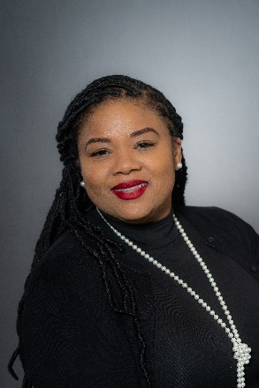  Monique Akanbi, SHRM-CP  Field Services Director-FSD  AL, BM, GA, MS, NY, TN, WV (interim for VA/DC)  monique.akanbi@shrm.org

