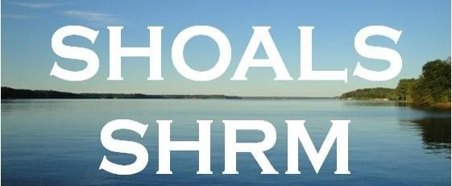
Shoals SHRM – Board Meeting
First Metro Bank
Meeting Minutes 12/9/2021

Call To Order at 1: 30 pm

Attendance
Crystal Wilson, President; Christina Lewis, Finance officer(via zoom); Matt Oglesby, Student Liaison; Kim Lafevor, Legislative Director (via zoom); Meghan Fike, Administrative Officer; Mallory Watkins, Communication Director; Absent – Pam Parker, Program Director

Topic | Discussion
Call to order | 2020 Matt Oglesby won a SHRM Foundation Scholarship  2021 Matt won a SHRM foundation Scholarship  Shoals SHRM donates to the SHRM Foundation each year.
SHRM VLRC VOLUNTEER  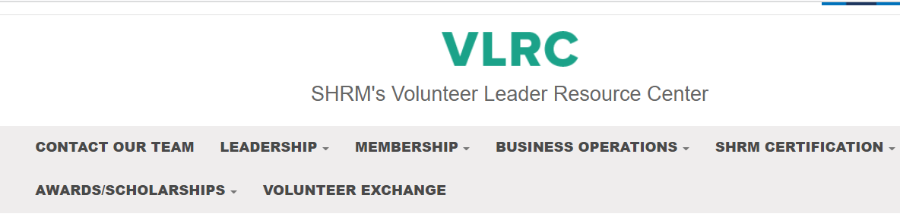 | https://community.shrm.org/vlrc/home  This website contains lots of help for board members.
Legislative Update – Kim LaFevor | Update  SHRM A-Team member.  Sign up here! Take Action Download the APP  http://www.advocacy.shrm.org/about?0  Local Legislative speakers – Jamie Kiel, Katie Brit. Kim will work on a legislative speaker for 2022.

Legislative Update – Kim LaFevor |  | All Hill Visit have been postponed until further notice A-team webcast 9/30/2021
Student Affairs – Chapter Advisors |  | Student SHRM national rates increase in $49
Student Affairs – Matt Oglesby |  | Matt update on UNA student chapter:  UNA students have been attending our webinars  --Election of officers  --Study Abroad 2022 tentative  Officers  MBA is growing around 67 students  Face to Face student conference – February 9  Auburn Montgomery
Income Statement/Finances-Christina Lewis 11/30/2021  SHRM Deposit for membership  Q2 Financial Support Program  100% Chapters: $6.25 per SHRM Professional Member primarily coded* to your Chapter at the end of each calendar quarter. Paid quarterly and totaling $25 per year. |  | Christina Lewis presents the Income  Statement as of 11/30/2021  Previous Balance -$ 11,848.47  Current Balance - $ 11,301.87  Chapter payments SHRM-$318.75  Membership payments $200  Keeping up with Jan 1 beginning and Dec 31 ending balance This is required for SHRM affiliation
 | Shoals Scholar Dollars 2022 |  | Will review in 2022
 | Membership Roster= previous 58 members  Current 51  Squareup-credit/debit card payment  (charges a fee so you don’t receive the full amount of the payment) $3.93  SHRM Dual Membership program 8/17/2021  Members can pay or register through SHRM.org for chapter membership  Paid members will receive a free 2021 $50 membership at no additional cost  (if we meet in person there will be a $15 food cost for anyone attending) |  | When requested submit Chapter Membership  Roster to Kevin Abbed (kevin.abbed@shrm.org  members must be SHRM National Members  New members  Robin Montgomery  Alma Landaverde  Sarah Jackson  Kara Pendergrass  Jacklyn Prather  9-Not renewed SHRM national membership (Allison Cole, Celena Grant, Cris Stephenson, Donna Jo Kent(retirement), Nick Conway, Gina Wilson, Emily Beavers, Jordan Lumpkins, Merkitha Malone, Jacquelun Allen, Kim Carmack, Christopher Klein, Carl Collins, Christopher Klein  (kim Lafevor not primary chapter)  Membership Cost 2022  January 1 - December 31, 2022  Membership –$50  $12 food cost - **changed to $10 for members,  Non-Member/Guest Food Cost $15  Approved membership dues  This is required for SHRM affiliation
 | College Relations – Budget  Kim - $50 student rate  February 23 & 24 – possibly send scholarships for this legislative conference. Kim many need some donations for students. |  | Matt Oglesby UNA Student Chapter 2022-Budget  Kim LaFevor Student 2022- Budget
 | Sponsorship Info  Bone & Joint |  | Paid Sponsorships none at this time
 | SHRM Foundation Change  https://www.shrm.org/foundation/Pages/Donate-Now.aspx  New Fundraising website for chapters and state council  https://shrm.org/foundation/about/Pages/GiveSmart |  | Supporting and promote SHRM Foundation  Initiative - SHRM Foundation $Change$ -  Made SHRM Foundation $1000  October 2022  Approved to make donation  This is required for SHRM affiliation
2021 ALSHRM SHRM FOUNDATION DIRECTOR FOR THE STATE Raised $2000 in Birmingham |  |  |  | 1/21/2021 ALSHRM Board meeting  4/8/2021 ALSHRM Board Meeting  7/29/2021 ALSHRM Board Meeting  11/5/2021 ALSHRM Board Meeting  ALSHRM Next one may be in person meeting in January/February 2022

Meeting Credits |  | Crystal Wilson has been submitting certification credits for meetings and conferences. HRCI & SHRM
UNA/SHRM Certification Study Group 2021  https://www.shrm.org/certification/about/Pages/default.aspx  Email or call Meghan Fike for promo code  mmfike@una.edu; 256-765-4289 |  | Each instructor must be SHRM Certified  SHRM certification exam window is  Instructors: Crystal Wilson, Ashley Butler, Rob Hildreth, Carol Underwood  Promoting SHRM Certification This is required for SHRM affiliation
Board Member Elections/Chapter Leader Information Form CLIF  https://fs16.formsite.com/robgatesshrmorg/form8/index.html |  | Survey Monkey online vote for board membersh  October/November 2021  We hope to find additional volunteer, possible students to help us with social media, flyers etc.as members at large  New board Members Pam Parker and Mallory Watkins interested in join Shoals Chapter  This is required for SHRM affiliation
SHAPE -Completed  https://drive.google.com/file/d/1WYhBfdWx96gkc1-ONk8iJkazhvwtqp33/view |  | SHAPE deadline is January 31, 2022 for our chapter initiatives.  Search for SHRM VLRC, may have to enter Shape in the search engine on the website for correct year 2021.Answer  7-10 questions  Required for SHRM Affiliations
Upcoming Board Meetings  1/2021  3/2021  8/2021 |  | This is required for SHRM affiliation
SHRM Annual Conference 2021  SHRM Annual Conference 2022 |  | Promote SHRM Expo Conference 2022-New Orleans, LA  June 12-15 2022
Communication Officer |  | -Update, Social Medial, Flyers (looking at students to help with this task for the chapter); maybe use Canva
Board Member Perks | Chapter will pay for Board members to attend UNA conference. if they chose to attend and their company will not pay  President, President Elect/Vice/ Past President, Finance officer, Administrative officer, Communication officer, Legislative and Student Liaison board member
Webinars & SHRM WEBINARS | Crystal has been sending out relevant webinars to the group  https://www.shrm.org/learningandcareer/learning/webcasts/pages/default.aspx
Upcoming Meetings 2021  January 2021-December 2021  Speaker Ideas -  HR Panel (3 or 4 people) with predetermined questions  Speakers Needed: 2022 | Thursday January 14, 2021, Building Trust Crystal Wilson  Thursday February 11, 2021-  Legal update Carr and Allison  Thursday March 11, 2021,  Joshua Sky Performance Management  Thursday April 8, 2021,  Donna Pearson Safety update  ALSHRM State Conference  May 4-5 2021 Birmingham, AL  Thursday May 13, 2021,  Keith Bray Identity theft and fraud  Thursday June 10, 2021 Kim Lafevor  July & August 2021 No Meetings
2021 Meeting Dates | Thursday September 9, 2021, Ethical Leadership Matt Oglesby  Thursday October 14, 2021, Outplacement, Danielle Dayries  Thursday November 11, 2021 Retirement Income Planning Stanley Morgan, Trey Belew  Thursday-Saturday November 11-12, 2021 SHRM Business Leadership Meeting Volunteers webinar online  Thursday December 9, 2021 Membership Promotion-Fun and Games First Metro Rhoda P’s catering need door prizes $10 per plate

2022 Meeting Dates  Need speaker  We will plan to meet in person unless speakers are unable to do so.  Mary Marshall VanSant will speak on Strategic Doing in 2022 | Thursday January 13 Patrick Sebesta Huntsville, AL Title VII Best Practices LGBT+  Thursday February 10 Carr and Allison Legal Update (may need to speak via zoom)  ALSHRM Legislative Symposium Reception will be on February 23, 2022 & February 24th, 2022 Montgomery, AL  Thursday March 10 Request SHRM Speaker?  Thursday April 14  Thursday May 12  ALSHRM Conference & Expo May 2-4 2022  June & July No meeting  June 12-15 2022 SHRM Expo Conference 2022-New Orleans, LA  Thursday August 11  Thursday September 8  Thursday October 13  Thursday November 10  Thursday December 8 Fun and Games
New Business – Combining Annual HR Conference & Workers Compensation Conference | We discussed combining the two annual HR conferences that UNA offers each year. This is due to declining numbers at each session in hopes that we can improve these numbers.  We will try this option in 2022 to see if it works.

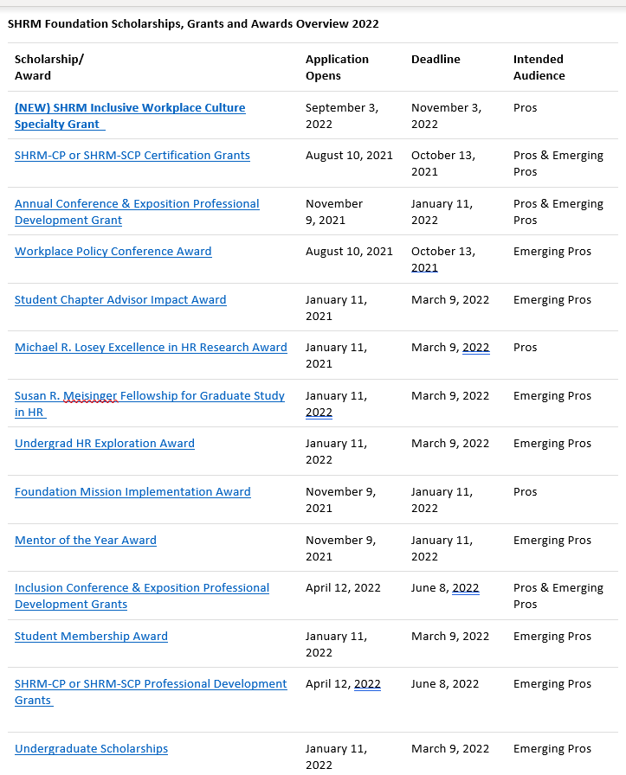
SHRM FOUNDATIONS SCHOLARSHIP 2022 link below
https://www.shrm.org/foundation/ourwork/scholarships/pages/all-deadlines.aspx

