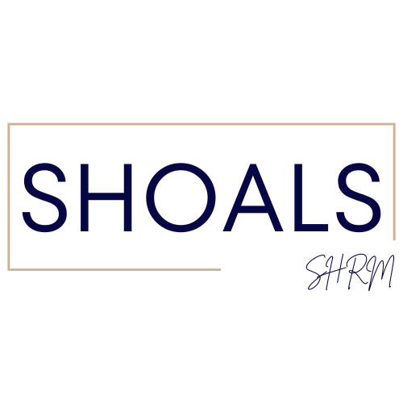
Shoals SHRM – Board Meeting
2/8/2024 1pm

Attendance
Mallory Watkins – President, Crystal Wilson - Past President/Certification, Meghan Fike - Administrative Officer, Christina Lewis - Finance Officer, Matt Oglesby - College Relations Officer, Shericeia Abernathy - Legislative Officer, Erika Franco - Communications Officer, Emily Collins - Communications Committee, Jessica Young
Absent None
Discussion/Meeting Notes
--SHRM Foundation change needs to be rolled.

--There was a good turnout for the package deal. $20 is a good price for guests. Invoices are being paid.

--SHAPE report and CLIFF are completed.

--ALSHRM meeting in Birmingham – Mallory, Erika, Cyrstal, Shericeia

--DC Legislative Update in April – Can Shericeia go?

--Listerhill was our meeting sponsor today – sponsorships are promoted on the website, Facebook, and social media

--Possible locations if we outgrow First Metro; Location could be a sponsor
Florence Public Library – 50 people; UNA – 50 people; Marriott – would have to pay for space; Cypress Lakes – would have to pay for space; Long-Lewis Building; Bank Independent; Stricklin Hotel ($500); Listerhill Auditorium; Pickett on Court; Pickett Place

--SHRM website – there is a problem with adding local members

--We need to reach out to members paying national dues but not coming….maybe a “we miss you” card.

--There could be a special drawing for people who bring a guest…guest voucher for every member?

--Member At Large List; National members not tied to any chapter…should we do a free voucher…do we have the right contact?

--Membership drive at the halfway point through rest of the year.

--We could spotlight local philanthropies and take donations for organizations our members are involved in. For example, Vision Board Community Project on February 23, 2024. Location Handy Rec Center.

--Student Chapter - Grace Williams, Grad Student, is helping with the chapter. They are conducting a virtual meeting – Let’s Talk HR with professors from around the country. Why does HR have a negative reputation?
3 to 4 students come to each Shoals SHRM meeting. They are receiving class credit.
--Bank Balance - $11, 704.18; we passed along the fee for square

--Should we bring back the SHRM conference for 2025? Monique could be a SHRM speaker

--Crystal is working on speakers; Erika suggested cocktails, after hours, Swampers; Should we have the Christmas party at the Stricklin hotel?

--We have 5 enrolled in the UNA/SHRM Certification class

--ALSHRM Conference – Should we sponsor a board member to attend? Can they apply for a conference scholarship? $399; Should they be a SHRM member, SHRM Chapter member, SHRM certified?

