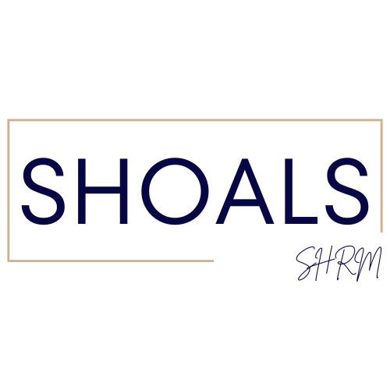
Shoals SHRM – Board Meeting
5/9/2024 1pm

Attendance
Mallory Watkins – President, Crystal Wilson - Past President/Certification, Meghan Fike - Administrative Officer, Christina Lewis - Finance Officer, Matt Oglesby - College Relations Officer, Shericeia Abernathy - Legislative Officer, Erika Franco - Communications Officer, Emily Collins - Communications Committee
Absent None
Topic | Discussion/Meeting Notes
Fall 2024 | October is booked; we have a sponsor for every fall meeting.  Membership Drive - $60 Discounted Cost for the rest of 2024  Erika Franco is helping with the newsletters and website  Christina Lewis noted $10,428.97 in the bank account  ALSHRM - $400 payment was made in support of Erika Franco’s trip to DC.  Mallory Watkins is attending ALSHRM next week. If you have any donations, please make sure that she gets those before she leaves.  Mallory is also attending SHRM National in Chicago  SHRM is redesigning the SHRM logo with chapter names underneath.  The UNA SHRM student group has officers – Jessica Diaz and Rachel Ford  The UNA SHRM class went very well this spring semester.  Maybe partner with Paylocity – HRIS System for students

