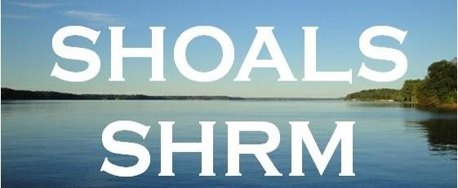
Shoals SHRM – Board Meeting
8/10/2023 1pm 2023

Call To Order at

Attendance
Crystal Wilson - President, Meghan Fike – Administrative Officer, Mallory Watkins – President – Elect, Matt Oglesby – College Relations, Erika Franco - Communication Officer, Committee Member - Emily Addison, Shericeia Abernathy – interested in joining board
Absent
Tim Tubbs - Legislative Officer Stepping down due to retirement; Christina Lewis - Finance Officer
Topic | Discussion
Call to order | Review a new Shoals chapter logo image.  Need board members to help meet, greet, serve, setup and clean during monthly meetings.  Tim Tubbs - Legislative Officer Stepping down due to retirement.  Board member election coming soon Survey Monkey
Required For SHRM Affiliation | REQUIRED For SHRM Affiliation- Southeast Region  Four Board Meetings Required Per Year  Income/Expenses - Keeping up with Jan 1 beginning and Dec 31 ending balance  Membership Dues - Members must be SHRM National Members $249  Supporting and Promoting SHRM Foundation Initiative - Make $1,000 donation from Shoals SHRM in October/November  Promoting SHRM Certification - UNA/SHRM Certification Study Group  Board Member Elections – October  Chapter Leader Information Form CLIF – Due December 1 or when board members change  SHAPE deadline is January 31, 2023 for our chapter initiatives and financial statement  Promote SHRM Expo, State Council Meeting, etc.  Annual Reaffirmation for SHRM certification provider  HRCI recertification for credits  VLBM Volunteer Leader Business Meeting (normally held in November)
Business Cards/Logo | Logo Mallory Watkins – Logo was approved
Bylaws | Sent revision to approve Bylaws: remove irrelevant information and Dual membership chapter. This will be an ongoing project. Monique FSD  SHRM bylaws have changed so much because so much is now housed through SHRM.
SHRM VLRC VOLUNTEER | Shrm.org-membership-volunteer leader resource center  Previous recorded volunteer webinars  Home (shrm.org)  Webinar (shrm.org)
Legislative Update – Tim Tubbs | SHRM A-Team member.  Sign up here! Take Action Download the APP  http://www.advocacy.shrm.org/about?0  Tim continues to keep us updated

Student Affairs – Matt Oglesby |  | Matt update on UNA student chapter:  STUDENT SHRM NATIONAL RATE $49  If more than 2 students attend the Shoals SHRM meetings, Matt will pay the $10 per student fee.  Future suggestion – maybe pay for a UNA student’s SHRM national fee ($49).  Students will be back on campus in August. Matt will offer students the option of coming to SHRM meetings for class credit.
Income Statement/Finances-Christina Lewis  SHRM Deposit for membership  Q2 Financial Support Program  100% Chapters: $6.25 per SHRM Professional Member primarily coded* to your Chapter at the end of each calendar quarter. Paid quarterly and totaling $25 per year. |  | Income Statement as of 8/8/2023  Purchased goody bags and gift cards for money meetings average around $50  Purchase Tea monthly average $12, purchase plates, cups, napkins, utensils as needed average $50 (will need to purchase supplies soon)  SHRM Foundation items 2023 purchased $86.35 Silent Auction  Mallory now has a debit card.  Previous Balance -$ 10,578  Current Balance - $ 10,597.86  Upcoming purchases Plane ticket for Washington DC $400-$500(SHRM pays for hotel), Post office Rental fee, SHRM Foundation Donation $1,000  Chapter payments 2022 SHRM Q4 $ $418.75  2023 SHRM Q1 $  2023 SHRM Q2 $  2023 SHRM Q3 $  Total National SHRM Members 57 (goes up and down, Crystal receives a daily report)  Post office $212.00 DUE September 2023  Meghan Fike membership $249 (varies annual)  Keeping up with Jan 1 beginning and Dec 31 ending balance  - This is required for SHRM affiliation  We have 27 paid package deals $2850  Possible locations – Listerhill Auditorium, Lauderdale County
Volunteer Activities/Workforce Readiness |  | Workforce Readiness Initiative for 2023-2024- Discuss hosting a job fair & partnering with the Shoals Chamber/Stephanie Newland and businesses. We can use Listerhill facility in Muscle Shoals for the job fair.  Date – Free – Promote  City of Florence, list of new businesses.  Shoals Chamber contacts  SHRM Host Free Webinars on the VLRC and HRCI for Credits
 | Membership Roster= members  Current 53  Squareup-credit/debit card payment  (charges a fee so you don’t receive the full amount of the payment) $3.93 |  | Members must be SHRM National Members $249  January 1 - December 31, 2023  Approved membership dues  This is required for SHRM affiliation  2023 Approved  SHRM NATIONAL members only  package deal - includes presentation and food  $100 OR $10 PER MEETING  Non-Chapter MEMBERS/VISITORS package deal  - includes presentation and food  $150 or $15 per meeting  Reach out to expired members
 | College Relations – Budget |  | Matt Oglesby UNA Student Chapter 2023 Study Abroad
 | Sponsorship Info |  | United way Donated Walmart $50 gift card 2/9/2023  United Way Donated Easter goody bag 3/9/2023  CIMSgts Ron Castro Sponsor $50 2/9/2023  Paycor is interested in sponsoring
 | SHRM Foundation Change  https://www.shrm.org/foundation/Pages/Donate-Now.aspx  New Fundraising website for chapters and state council  https://shrm.org/foundation/about/Pages/GiveSmart |  | Support and promote SHRM Foundation  Initiative - SHRM Foundation $Change$ - Collecting change in 2023  Make a $1,000 donation from Shoals SHRM in November 2023 - This is required for SHRM affiliation  **Foundation Scholarships Handout**  There are free opportunities available for members
 | 2023 ALSHRM SHRM FOUNDATION DIRECTOR  Crystal Wilson  ALSHRM BOARD MEETING 1/26/2023 |  | SHRM Foundation 2023  ALSHRM Conference May 15-17 2023 Perdido Beach Resort  SHRM FOUNDATIONS SCHOLARSHIP 2023 available online  https://www.shrm.org/foundation/pages/default.aspx
Erica Franco  Emily Addison |  |  | Updates on workforce development

Meeting Credits |  | Crystal Wilson has been submitting certification credits for meetings and conferences - HRCI & SHRM  October 2022 Complete Re-affirmation for SHRM Chapter Certification Provider for 2023  Completed HRCI Renewal January 2023  Chapter Certification
UNA/SHRM Certification Study Group 2023  https://www.shrm.org/certification/about/Pages/default.aspx  SHRM HOST CERTIFICATION WEBINARS  YOU CAN REPLAY THEM ON THE SHRM VOLUNTEER WEBSITE SHRM Volunteer/Core Leadership Area (CLA) Webcast/Webinar Information 2022 |  | Each instructor must be SHRM Certified  2023 SHRM certification exam window is May – July & December – February  Instructors: Crystal Wilson, Mallory Watkins, Rob Hildreth, Carol Underwood  Promoting SHRM Certification This is required for SHRM affiliation – Post on Facebook & LinkedIn  SHRM eblasts for certification prep course (non – SHRM affiliated members)  Carol will not be teaching after this year. Matt Oglesby can possibly take her place. Also, Shericeia Abernathy just received her SHRM certification.  UNA’s new BBA program in Human Resources will encourage students to get certified.
Board Member Elections/Chapter Leader Information Form CLIF  https://fs16.formsite.com/robgatesshrmorg/form8/index.html |  | SURVEY MONKEY FOR BOARD MEMBERS SEND OUT IN OCTOBER 2023  This is required for SHRM affiliation  Not many people fill these out.  We may need to send out two different surveys…one with nominations and one final one. We could use a QR code.
SHAPE -Completed  https://drive.google.com/file/d/1WYhBfdWx96gkc1-ONk8iJkazhvwtqp33/view |  | SHAPE deadline is January 31, 2023 for our chapter initiatives and financial statement COMPLETED JANUARY 2023 will be due 2024  Search for SHRM VLRC, may have to enter Shape in the search engine on the website for correct year. Answer  7-10 questions  Required for SHRM Affiliation  This is where we add and delete board members.
Board Meetings  4/2023  8/2023  10/2023  12/2023 |  | This is required for SHRM affiliation
SHRM Annual Conference |  | SHRM EXPO CONFERENCE 2024 June 23-26 Chicago, IL
Communication Officer |  | Mallory Watkins, Meghan Fike, Crystal Wilson - Update, Social Media, Flyers
Board Member Perks | Chapter will pay for Board members to attend UNA conference (if there is a conference held) if they chose to attend if their company will not pay  President, President-Elect/Vice/ Past President, Finance Officer, Administrative Officer, Communication Officer, Legislative Officer, Student Liaison board member, Program Director, Communication Director
Webinars & SHRM WEBINARS | Crystal has been sending out relevant webinars to the group and posting on the website  Meghan Fike has started our Shoals SHRM Facebook page and updating upcoming events  Mallory has started our LinkedIn SHRM page  https://www.shrm.org/learningandcareer/learning/webcasts/pages/default.aspx
Company Foundations | Kicks For Kids, Food Pantry, Toys For Tots, United Way, Books

2023 Meeting Dates  Need speaker  We will plan to meet in person unless speakers are unable to do so. | CRYSTAL ATTENDED  Thursday November 17-19, 2022 Gaylord Convention Center, Washington, D.C. (details to come)  Thursday, January 12, 2023 Blake Cruttenden DRUG FREE WORKPLACE SUPERVISOR TRAINING  Drug and Alcohol Mis-use in the Workplace  Wednesday January 25 ALSHRM HR Innovation $29  Thursday January 26 State Council meeting Auburn Opelika Resort (no cost) Mallory and Crystal will be attending  Thursday, February 9, 2023 ETHICS Legal update Carr & Allison  Thursday, March 9, 2023 Mr. John Mansell & Mr Wesley Puckett Lauderdale County School System  Thursday, April 13, 2023 Horizon Point Jillian Miles  Thursday May 11, 2023 Patrick Sebation Attorney  Monday-Wednesday May 15-17 2023 ALSHRM Conference and Expo Perdido Beach Resort Orange Beach AL Crystal Will be attending as ALSHRM Foundation Chair  June 11-14, 2023 Las Vega NV Convention Center  SHRM Annual Conference & Expo 2023  Thursday, August 10, 2023 Tosha Page UNA  Thursday September 14, 2022 Verk Vibe Jon Orozco Laurie (Lawrence)  2023 ALSHRM Employment Law & Compliance Conference  September 18-20th, 2023 Register Montgomery https://elcc.alshrm.org/?mc_cid=8d65372fc3&mc_eid=2446ac4ebc  Thursday October 12, 2023 Crystal and Mallory (HRCI or SHRM Video with Credits)  SHRM Website & Chapter Website  Thursday, November 9, 2023 – Robin Hunt Think Analytics  Save the Date: SHRM Volunteer Leaders' Business Meeting (VLBM) 2023: November 16-18, 2023, Washington, D.C. Invitation-only for select State Council and Chapter positions; more details to come. Mallory and Crystal Plan to attend  Thursday, December 14, 2023 – Holiday Open House Need to work on door prizes and Games  2024 Upcoming Events  Thursday January 11, 2024 Horizon Point Mary Ila Ward or Jillian Miles  Thursday February 8, 2024 Carr/Allison Legal Update  Thursday March 14, 2024 Cierra Belser (ALSHRM) Breaking Barries: Inclusive Hiring Practices for Employers  Thursday April 11, 2024 Dr Ryan Gibson HPG Holistic Performance group Decatur-Thea Harvey-Barratt Emotional Intelligence  Thursday May 9, 2024 Need Speaker – Matt Oglesby will speak  May 2024 ALSHRM Conference more details to come – Gulf Shores  June 23-26 SHRM Annual Conference and Expo Chicago, IL  Thursday August 8, 2024 Rene Ramsey ALSHRM  Thursday September 12, 2024 Need Speaker  Thursday October 10, 2024 Need Speaker  Thursday November 14, 2024 Need Speaker  SHRM Volunteer Summit Washington DC more details to come November 2024  Thursday December 12, 2024 Open House Fun and Games  CONFERENCE AWARDS SHRM Foundation  Scholarship/ Award Application Opens Deadline Intended Audience  Annual Conference & Exposition Professional Development Grant November 12, 2023 January 10, 2024 Pros & Emerging Pros  Employment Law Event Grant August 8, 2023 October 11, 2023 Emerging Pros  Inclusion Conference & Exposition Professional Development Grants April 9, 2024 June 12, 2024 Pros & Emerging Pros  Foundation Mission Implementation Award November 12, 2023 January 10, 2024 Pros  Mentor of the Year Award  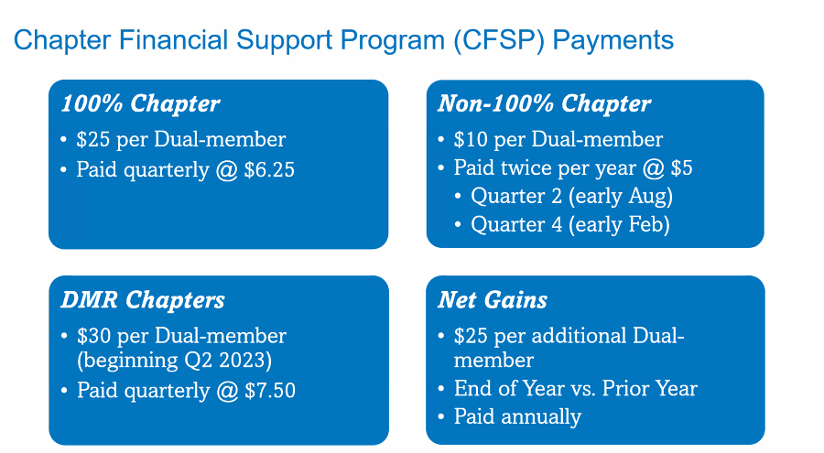  Southeast Region-Alabama, Bahamas, Bermuda, District of Columbia, Florida, Georgia, Kentucky, North Carolina, Mississippi, Puerto Rico, South Carolina, Tennessee, Virginia, West Virginia  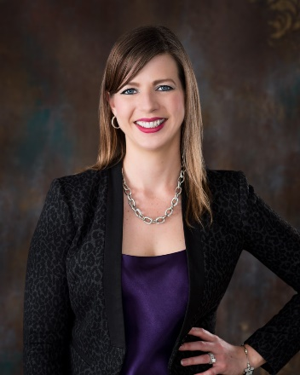  MAC Representative Heather "HD" Deyrieux, SHRM-SCP Manager - Workforce Planning  Sarasota County Government Sarasota, FL Email: HDshrmMAC@gmail.com  State Council Websites  Alabama -- http://al.shrm.org/ Bermuda -- http://www.bhra.bm/  Bahamas -- http://bhrda.shrm.org/ Georgia -- http://shrmga.shrm.org/  Florida -- http://www.hrflorida.org/ Kentucky -- http://www.kyshrm.org/  North Carolina -- http://nc.shrm.org/ Mississippi -- http://www.msshrm.org/  Puerto Rico -- http://www.shrmpr.org/ South Carolina -- http://sc.shrm.org/  Tennessee -- http://tnshrm.shrm.org/ Virginia -- https://www.hrvirginia.org  West Virginia -- http://wv.shrm.org/  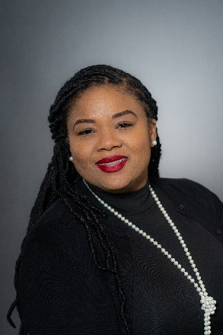  Monique Akanbi, SHRM-CP  Field Services Director-FSD  AL, BM, GA, MS, NY, TN, WV (interim for VA/DC)  monique.akanbi@shrm.org

